**Exp. 14 Virtual Machine using Azure**

**Aim:**

Demonstrate Infrastructure as a Service (IaaS) by creating a resources group using a Public Cloud Service Provider (Azure), configure with minimum CPU, RAM, and Storage.

**Procedure:**

* Sign in to Azure Portal
* Create a Resource Group
* Create a Virtual Machine (VM) inside the Resource Group
* Configure Disks for storage and networking
* Review and create the virtual machine.
* Verify the deployment

**Output:**

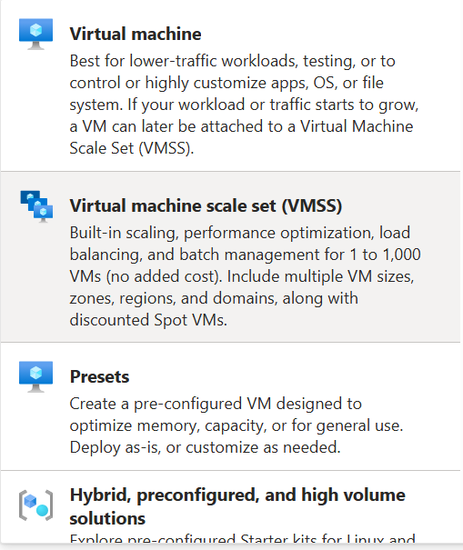

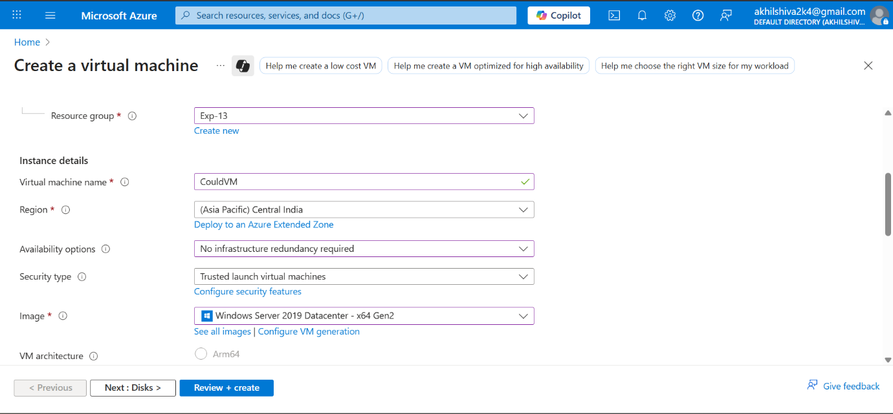

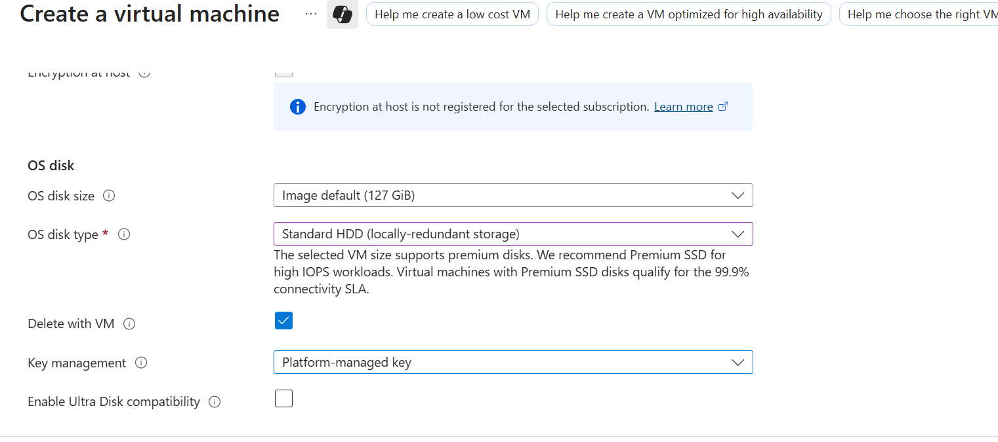

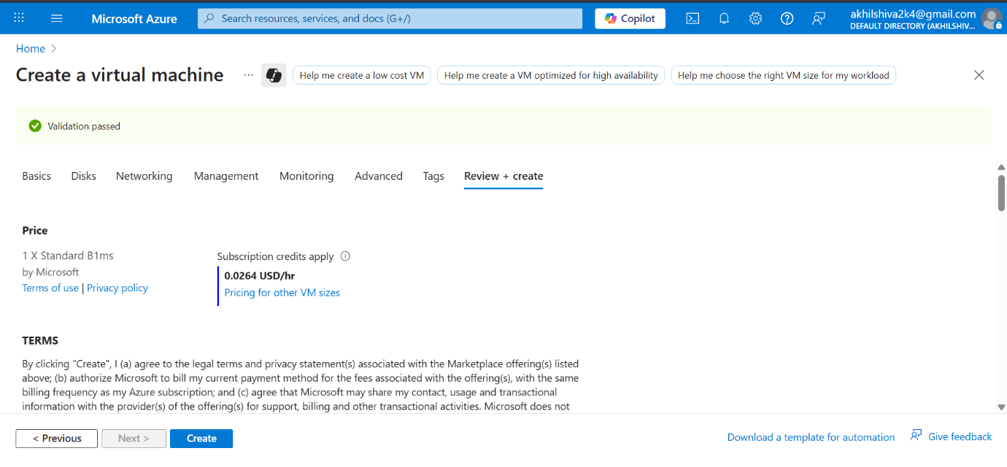

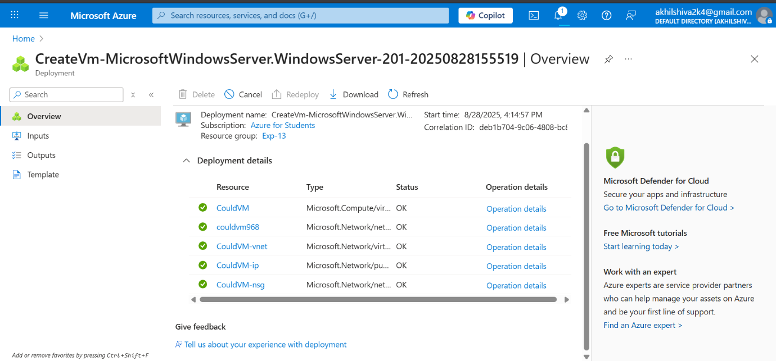

**Result:**

Thus the Virtual machine was created successfully using Azure